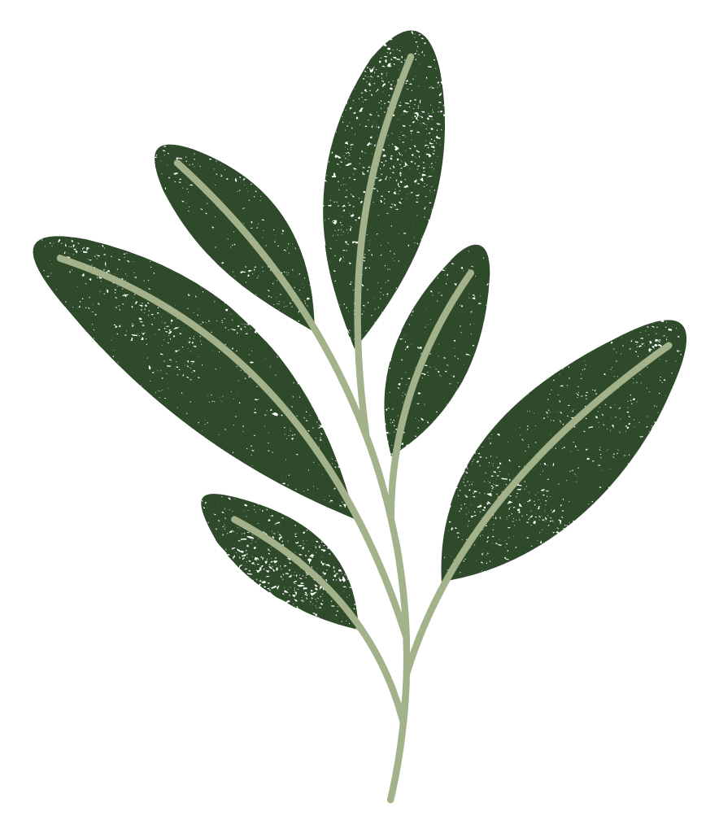
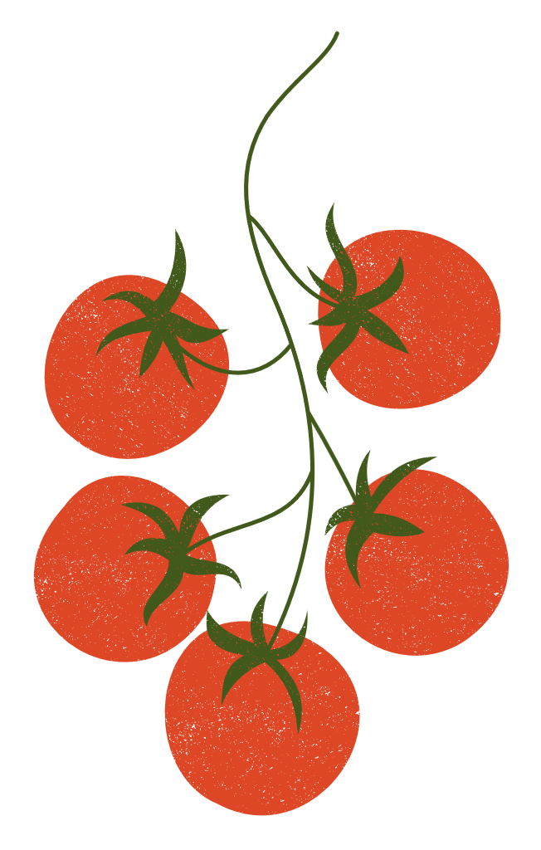
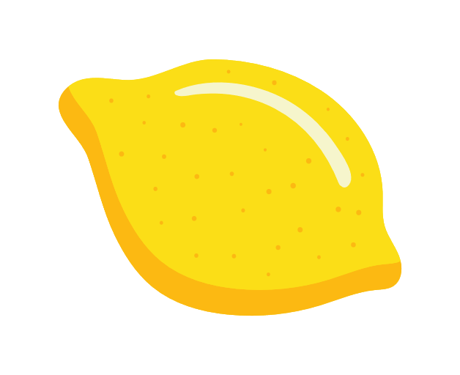


Seed Companies

Local to Washington
- Deep Harvest Farm (Whidbey Island)
- Wild Dreams Farm (Vashon)
- Ed Hume Seeds (Puyallup)
- Osborne Seeds (Mt. Vernon)
- Silvaseed (Roy)
- Uprising Seeds (Bellingham)
- Seattle Seed Company (Seattle)
- Irish Eyes Garden Seeds (Ellensburg)

Local to PNW
- Territorial Seed Company (Oregon)
- Adaptive Seeds (Oregon)
- Siskiyou Seeds (Oregon)
- Wild Seed Garden (Oregon)
- Peace Seedlings (Oregon)

National
- Alliance of Native Seed Keepers
- Seed Savers Exchange
- Burpee
- Back to the Roots
- Pinetree Seeds
- Victory Seed Company
- Hudson Valley Seed
- High Mowing Seeds
- Ferry Morse
- Bucktown Seeds
- Eden Brothers (tentative – affected by Hurricane Helene)
- Baker Creek Seeds
- Botanical Interests
- Second Generation Seeds
- Strictly Medicinal Seeds
- Renee’s Garden

